**Problem Statement**

*Mention the problem you are trying to solve or the reason behind the project*

Introduce a practice partner for individuals seeking to practice table tennis without any training buddy.

**Idea**

*A general description of your solution*

A device that would project balls to the player and keep a score of the number of returns made back to the other side of the table.

**Prototypes and rejected versions**

*Mention all the brainstorming points and different ideas discussed and the reason for selecting the final idea(add images and sketches)*

*Paper prototype*

**{Images}**

1. Our first idea was based on sustainability and making a dustbin that would use sensors and technology to automatically segregate waste thrown inside for healthy waste disposal.

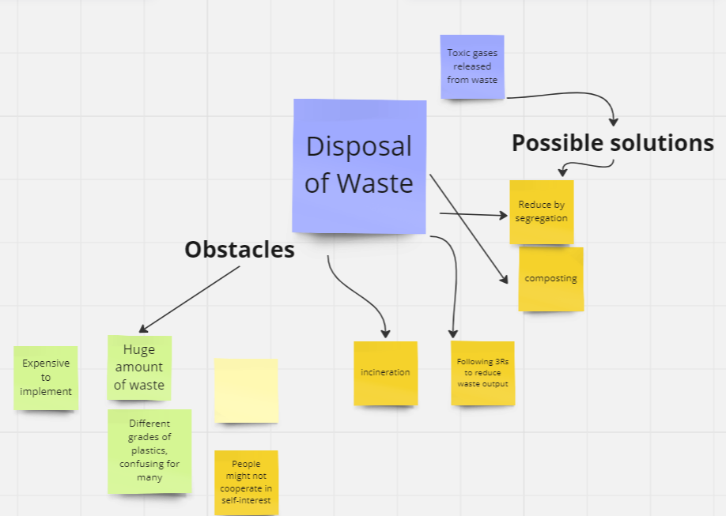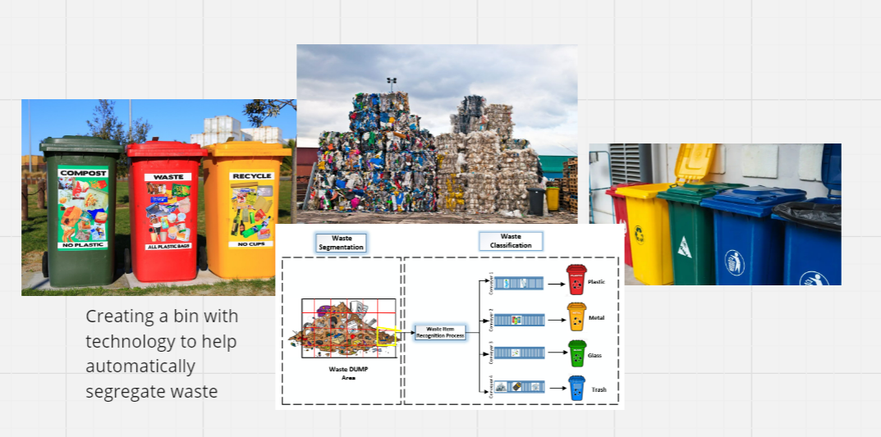

However we quickly realized that it wouldn’t be easy to include technology that could automatically sense the material that is being thrown in. Or if it was to sense, it’d take a few years to develop. Therefore, we had to forego this idea.

1. Our initial idea for table tennis was to develop a robotic racket that would potentially return a serve given by a player. As a group, we conducted a lot of research based on. We did realize that the component of requiring ball tracking was crucial and difficult to incorporate within such a short time. Along with ball tracking, we also need quick technology to identify where and what the ball looked like and predict its trajectory for the racket to hit it on spot. This again seemed difficult to cover in the time period. Therefore, we simplified the project to our final one while adding unique aspects to it.

We ensured that the final idea was challenging in some aspects, but would overall provide a positive objective after the project was complete. While knowing the time/resource limit we would have to work within, our final idea of a table tennis ball projecting machine that also keeps track of returns seemed perfect to continue.

**Final Project idea /Solution**

*Describe the final project idea*

Our final project aims to provide a practice partner for a table tennis player. Essentially, the solution is to build a ball projecting machine that is versatile to different difficulty levels. The use of stepper motors, DC motors, and servo motors would primarily provide the function of ball projection as required. While ensuring successful ball projection to the player, the project would also keep track of if the player has managed to successfully return the projection to the other side of the table. This will be tracked using vibration sensors placed on the player’s racket as well as the machine-side of the table. If both sensors indicate vibrations, that will show that the player has returned the ball to the other side of the net. With this project, we hope to create an innovative solution to allow players to practice with consistency and less dependency, making it more engaging as well.

**objectives of the project**

*State the objectives of your project precisely and distinctly*

* Training of athletes without the need of a second player/coach.
* Keeping track of scores precisely to ensure fair play.
* Project balls to cater to difficulty levels based on the player’s ability in table tennis, from beginner to advanced.
* Develop player’s skill of reflex, accuracy, and technique by projecting shots in various yet consistent styles.
* Monitor and collect data on the player’s performance by keeping track of the returns of projections that the player successfully makes.
* Allow the user to customize speed, spin, frequency, and trajectory of the balls to better suit their practice.
* Create an engaging and fun tool that encourages physical activity within all age groups and makes improving table tennis easier.

**Block diagram based on objectives**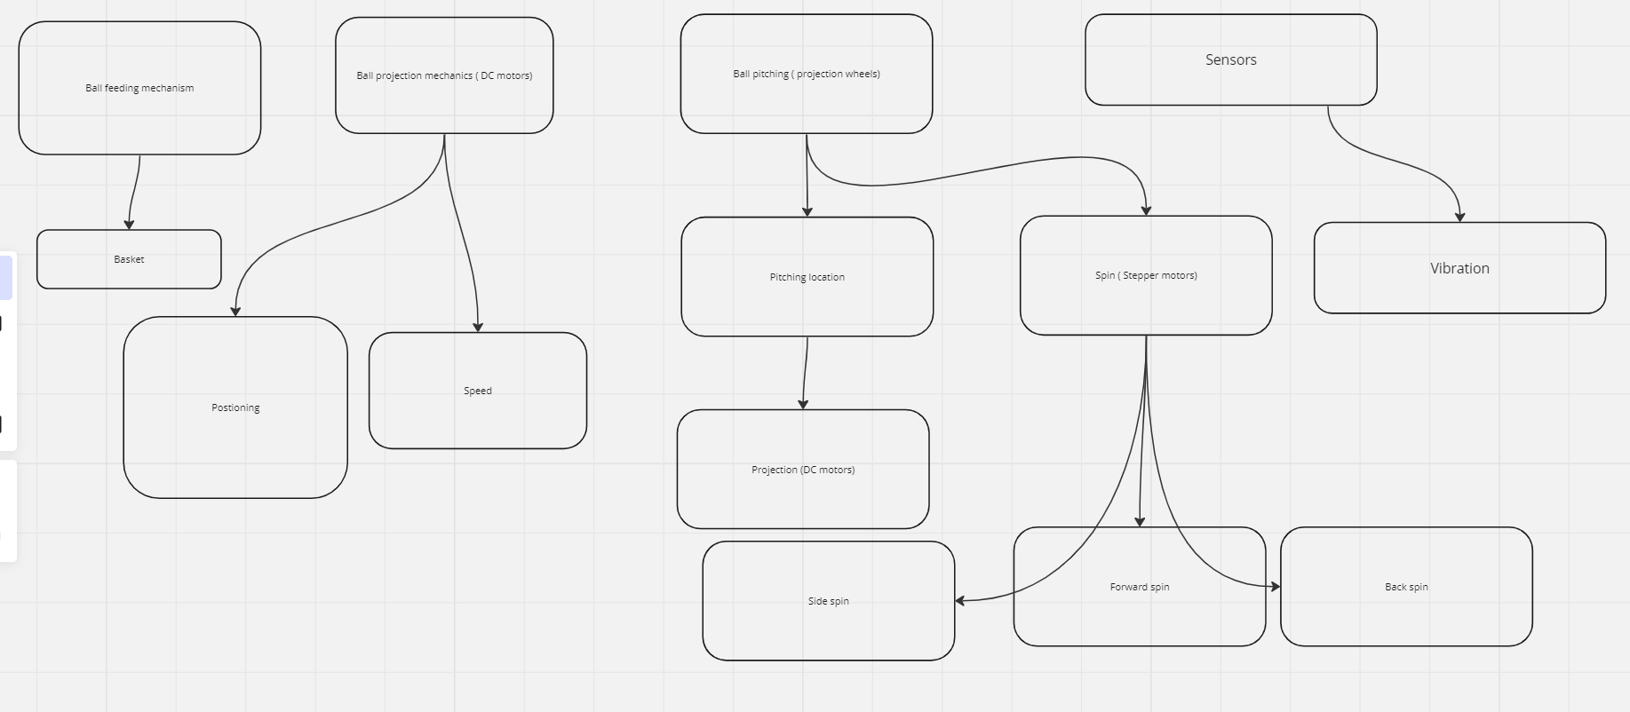

**Materials based on Block diagram**

*Create a Component list for every block and the whole project*

Ball projection

* Stepper motors
* DC motors
* 3D printed gears
* Projection wheels

Ball loading/collection

* Basket
* Net

Support

* Wooden platform

Sensors

* Vibration sensors

Other resources

* Arduino UNO
* Buttons
* Wires
* Solder wire

**Working of Individual block**

*Create test cases for individual block*

Information about How to use and test every block separately

**Logic of the complete program**

*Prepare a logic for the whole program and mention in steps how it is supposed to work*

**The device has two functions; i) Ball projection, ii)Recording score**

**Ball projection**

1. The user chooses the settings for the spin, place and pace at which the ball is required to be delivered.
2. The arduino gathers requirements and assigns values to each motor, with a certain delay
3. After each ball is loaded, motors spin at the required speed and duration to deliver the ball
4. While the motors keep running, balls are fed into the slot, launching after the set delay.

**Recording the score**

1. Two vibration sensors; one placed on the table of opponents end and one placed on the players racket.
2. Contact must be made with both sensors in order to obtain a point.

**Assembly and debugging**

*Assembly procedure and changes required in program*

*Problem faced and how they were resolved*

**Source Files Folders:**

**Refer to** [**https://github.com/arrnavvchawla/The-Waterminder**](https://github.com/arrnavvchawla/The-Waterminder) **as an example**

* **Source Files**
  + **Docs**
    - Main Project Document
    - Technical Document
    - Resource and reference list
  + **Images**
    - Brainstorming and paper prototyping Images
    - Block diagram
    - Sketches of custom parts (if required)
    - Special Components
    - Circuit diagram for testing individual component
    - Circuit diagram for main project
    - Work in progress images
    - Assembly Steps
  + **Videos**
    - Working of individual components and blocks
    - Working of main project
    - Assembly Video
  + **Codes**
    - Test code for individual components and blocks
    - Final Project Code
    - Libraries used
  + **CAD**
    - 3D printed part physical images, images, and CAD files
    - Laser cut part images and cad files